**Pressure Distributions Over an Airfoil to Calculate Lift and Drag**

Charles Keer

AE315

*Department of Aerospace Engineering*

*Embry-Riddle Aeronautical University, Daytona Beach, FL, 32114-3900*

**Introduction**

Reading pressure distributions across an airfoil can be very useful in characterizing the airfoil as well as calculating important values such as the coefficient of lift, drag, and pressure. For the experiment conducted, an airfoil cross section was placed in a wind tunnel where pressure readings and wake scans were conducted at different angles of attack at a constant freestream velocity. Utilizing the wake scan and the pressure distribution data, the airfoil can then be characterized.

**Results and Discussion**

This experiment was performed in an open-circuit wind tunnel on a GA(W)-1 airfoil cross section with an approximate 30cm chord length. The velocity of the freestream was 20m/s and was measured using a pitot-static tube at the test section inlet. The airfoil was set with screws, attached to the side of the wind tunnel. A level was used to verify the angle for each experiment. Static ports were located across the chord of the airfoil on both sides.

**Table 1.** Initial Conditions

|  |  |
| --- | --- |
| Initial Test Conditions | Values |
| V∞ | 20 m/s |
| P∞ | 101.7 kPa |
| T∞ | 294.26 K |
| M͏∞ | 0.0582 |
| Q∞ | 0.241 kPa |
| Reynolds Number | 402000 |
| Chord Length | 30 cm |

These ports were connected to a DAQ that recorded data during the experiment. Two ports were also added to measure the static and total pressure. These values could be subtracted to determine the dynamic pressure which is necessary for find the coefficient of pressure. Additionally, a pitot-static port was fixed on a vertically moving arm directly behind the experimental cross section. This port measured the wake of the airfoil. The wake probe at the rear of the airfoil was moved slowly in increments to read the wake pressure. This was done for all angles of attack. Initially, a coarse scan was employed to find the range where the wake was located. A fine scan was then used to get more precise readings.

Using the pressure distributions, the coefficient of pressure across the airfoil chord was calculated for each angle of attack. Figures 3 and 4 are examples of this at zero and positive two degrees respectively. Integrating the curve for the coefficient of pressure yields the lift Diagram, schematic
coefficient at that point along the chord of the airfoil.

**Figure 1.** Schematic of the test setup for pressure distribution (not to scale).

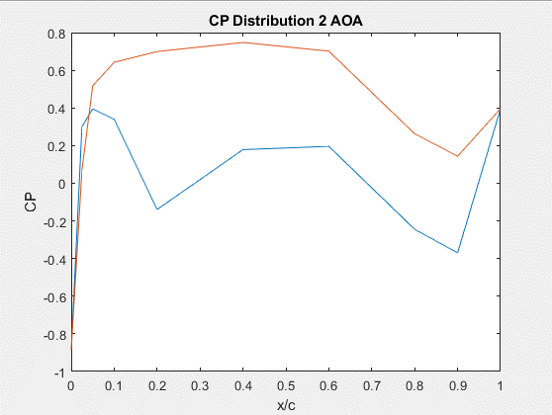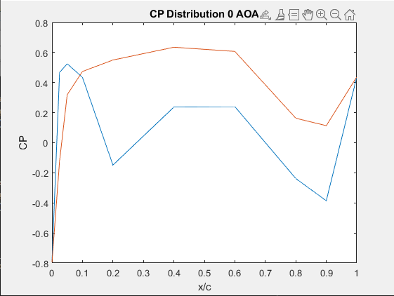**Figure 2.** Location of pressure ports along the airfoil chord.

**Figure 3.** CP Distribution at 0 AOA **Figure 4.** CP Distribution at positive 2 AOA

The coefficients of lift for each angle of attack were computed and are listed in Table 2.

**Table 2.** CL values corresponding to AOA

|  |  |
| --- | --- |
| Angle (degrees) | Coefficient of Lift (CL) |
| -4 | -0.1099 |
| -2 | 0.1845 |
| 0 | 0.3485 |
| 2 | 0.4898 |
| 4 | 0.7943 |

**Table 3.** CD values corresponding to AOA

|  |  |
| --- | --- |
| Angle (degrees) | Coefficient of Drag (CD) |
| -4 | 0.0017 |
| -2 | 0.0016 |
| 0 | 0.00029 |
| 2 | 0.0022 |
| 4 | 0.0001 |

**Table 4.** Pitching moment about the leading edge corresponding to AOA

|  |  |
| --- | --- |
| Angle (degrees) | Pitching Moment |
| -4 | 0.0082 |
| -2 | -0.0138 |
| 0 | -0.0261 |
| 2 | -0.0367 |
| 4 | -0.0596 |

**Table 5.** Pitching moment about the quarter chord corresponding to AOA

|  |  |
| --- | --- |
| Angle (degrees) | Pitching Moment |
| -4 | -0.0192 |
| -2 | 0.0323 |
| 0 | 0.0610 |
| 2 | 0.0857 |
| 4 | 0.1390 |

The coefficient of drag was calculated by looking at the wake scan pressures immediately after the airfoil. It should be noted that the wake scan did not contain a large amount of data points, meaning that the CD will be rather inaccurate. This can be verified by observing the inconsistent drag coefficients in Table 3. However, it can be observed the differences in the wake scans between two angles of attack. The larger angles of attack have a deeper and wider wake compared to the zero angle of attack. The pitching moments about the leading edge as well as the quarter chord were tabulated through integrating the coefficients of pressure and then multiplying them by a moment arm. This data seems to be accurate, as there is a negative trend in the pitching moment as the angle of attack increases. The quarter-chord data can also be Chart, line chart
considered accurate as there is a positive trend in the data as the angle of attack increases.

**Figure 5.** Wake scan at 0 AOA **Figure 6.** Wake scan at positive 2 AOA

**Conclusion**

Using both pressure coefficients and wake scans is an effective way to characterize an airfoil. It can clearly be seen the difference in how the GA(W)-1 airfoil performs at different angles of attack. It was found that as the angle of attack increased, so did the coefficient of lift and drag. This is to be expected and is corroborated by the NASA data provided by the lab instructors.

**References**

Department of Aerospace Engineering, *AE 315 Lab 2,* Canvas.

<https://erau.instructure.com/courses/139804/assignments/2770675?module_item_id=8477535>

Department of Aerospace Engineering, *AE 315 Lab 2 Background*, Canvas.

[Lab2_background.pdf: AE 315 Experimental Aerodynamics Lab - SPR 2022 - In Person (instructure.com)](https://erau.instructure.com/courses/139804/files/29486307?module_item_id=8433250)

McGhee, R. J., & Beasley, W. D. (1973). *Low-speed aerodynamic characteristics of a 17-percent-thick airfoil section designed for general aviation applications*. National Aeronautics and Space Administration.